
Year 10

Mini Test 6 Pathway 1

Statistics

Resources allowed: Calculator and 1 x A4 page one side
Name: ______________________ Class: ______ Time: 55 minutes Total Marks: ____/70
Show working and answers on this sheet. Show working in sufficient detail to support your answers. Incorrect answers without supporting reasoning may be allocated zero marks.

Question 1 (2,2 – 4 Marks)
- Plot the following points onto the graph.
(1, 1.5), (1, 2.5), (3, 2.5), (4, 1), (5, 2), (6, 0.5), (7, 0.5), (8, 1)

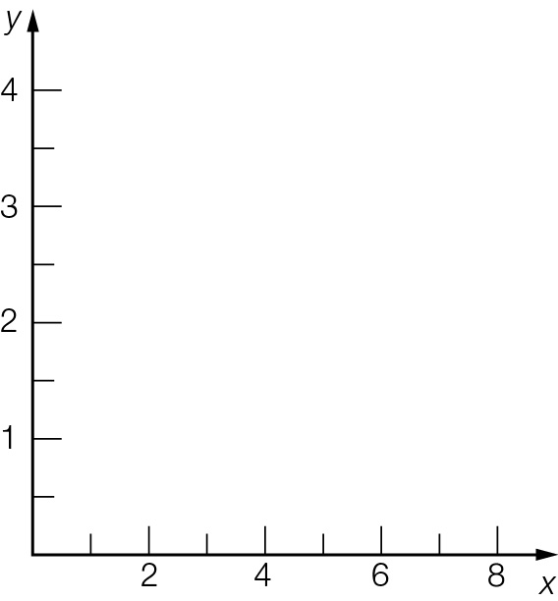
- Describe the relationship between x and y.

Question 2 (1,1,1,1 – 4 Marks)
In a market survey, 200 people were asked how many hours of television they watched in the previous week. The results are presented in the boxplot below.
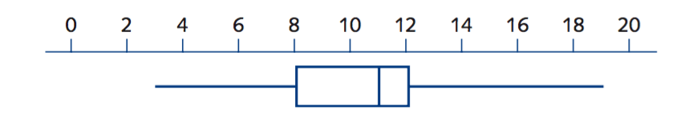
- What is the maximum number of hours anyone watched television?

- How many people watched more than 8 hours of television?

- What is the interquartile range?

- How many people watched between 8 hours and 11 hours of television?

Question 3 (3,2 – 5 Marks)
The boxplot shows the distribution of test scores in a class (Class A) of 20 students.

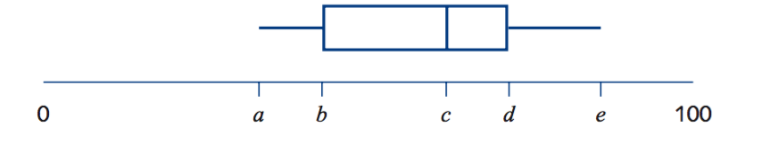

The lowest score in the class was 38, the range of the scores was 50 and the median was 61.

- Write down the values of a = c = e =

- When all the test scores were added up the total was 1240. What was the mean of the test scores?

Question 4 (1, 1 ,2, – 4 Marks)
The stem‐and‐leaf plot shows the distribution of test 4 47 scores in Class 10.7 for the same test.
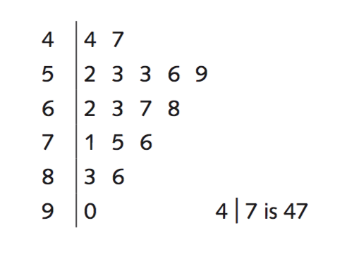
- Assuming all students sat for the test, write down the number of students in Class 10.7.

- Find the median of the scores for Class 10.7.

- Find the Mean Score for the Class

Question 5 (4 Marks)
The daily maximum temperatures recorded for a two-week period are shown in the table below.

Week 1 | 18.2 | 22.5 | 17.6 | 24.6 | 15.4 | 19.5 | 16.3
Week 2 | 25.6 | 28.2 | 29.0 | 28.5 | 33.2 | 28.8 | 30.4

- Find the mean and standard deviation of the temperatures for both weeks. Give your answers correct to one decimal place.

Question 6 (1, 1,2, 2 -6 Marks)
The Cats and The Mice basketball teams compare their number of points per match for a season. The data is presented in this back-to-back stem-and-leaf plot.
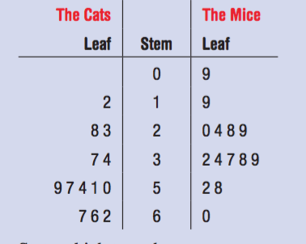

State which team has:
- the higher range

- the higher median

- the higher mean

- the higher standard deviation

Question 7 (3,2,2 -7 Marks)
The number of late passes issued daily by a school over a four week period were as follows:

8, 7, 7, 7, 9, 6, 5, 4, 14, 4, 6, 8, 10, 6, 5, 4, 8, 7, 9, 9

- Determine the five number summary for this data.

- Is the value of 14 in the above list an outlier for the data set? Justify your answer.

- Use the five number summary to construct a box plot on the scale below that reflects your response in (b).

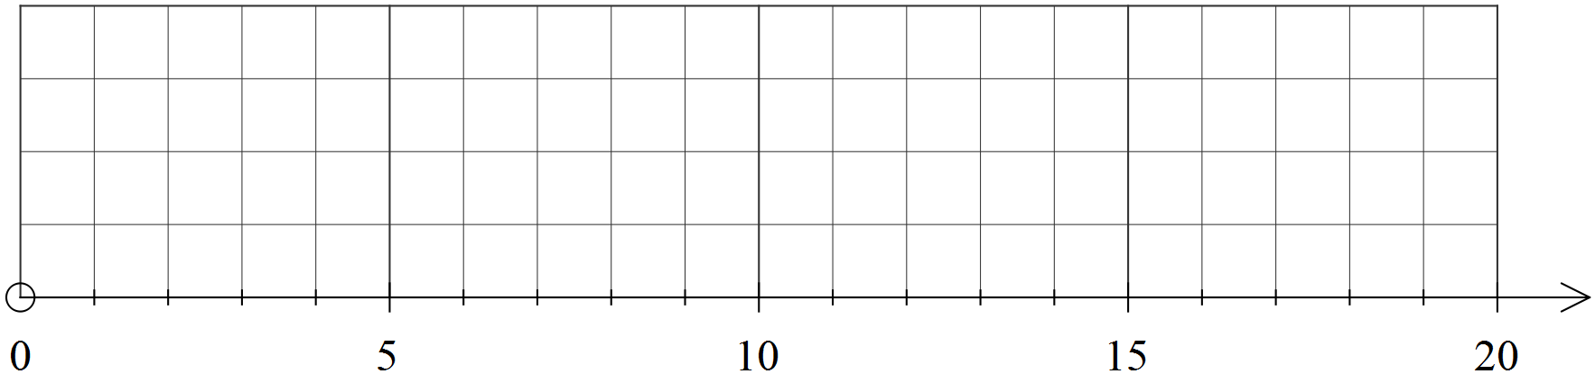

Question 8 (3 marks)
Two classes are marked on the same tests.
Class P has a mean of 65% and standard deviation of 5.
Class Q has a mean of 50% and standard deviation of 15.
- Write a statement comparing the scores of the two classes, that is who had the better scores?

- Write a statement comparing the spread of the scores for the two classes.

- Which class would you expect to have the highest score? Explain.

Question 9
(1,1,2,2,2 – 8 Marks)
Two PE classes of students have their pulse rates (in beats per minute) measured. The results are shown in these box plots.
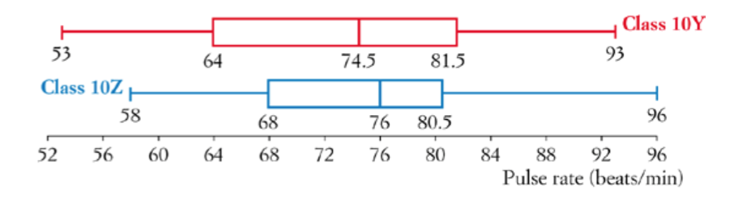
- What was the lowest pulse rate across both classes?

- Find the interquartile range for class 10Z.

- If there are 24 students in class 10Y, how many had a pulse rate between 74.5 and 81.5?

- Which class had the higher pulse rate on average? How does the box plot show this?

- Which class had more spread of pulse rates? How does the box plot show this?

Question 10 (5, 4,4 -9 Marks)
The data below gives the average monthly minimum daily temperatures of two Australian cities. The months are in order: January to December.

City X: 11.2, 11.8, 13.2, 9.3, 7.4, 5.8, 4.3, 5.9, 6.9, 19.8, 18.3, 12.4
City Y: 23.2, 22.6, 18.4, 14.5, 7.2, 4.1, 3, 6.9, 8.7, 13.1, 18.3, 22.4

(a) Find the five-number summary for each city.

(b) Draw a parallel box plot for the two cities.


(c) Write a couple of sentences comparing and contrasting the two cities.

Question 11 (2,1,1,1,1 - 6 Marks)
The height of a seedling after the first shoot appears is recorded in the table below.
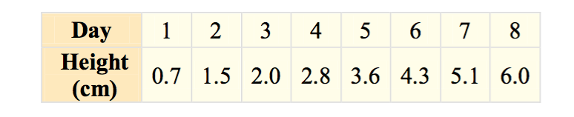
- Plot the points in a scatter plot in the grid below. 
- Describe the relationship between the day and the height.

- Draw in the line of best fit.

- Use the graph to find the height after 2.5 days. What is this prediction called?

- Use your answer to e to predict the height be after 10 days. What is this prediction called?

Question 12 (4, 4, 2 - 10 Marks)
A group of 16 people was surveyed to find the number of hours of television they watch in a week.
The raw data is listed: 6, 5, 11, 13, 24, 8, 1, 12 7, 6, 14, 10, 9, 16, 8, 3
- Organise the data into a table with class intervals of 5.

- Construct a histogram for the data.

- Would you describe the data as symmetrical, positively skewed or negatively skewed?

~End of Test~

